Task 2
Stock Portfolio Tracker
Objective
The objective of this project is to build a simple stock portfolio tracker using Python. The program allows the user to enter stock names and quantities, uses manually defined stock prices, and calculates the total investment value.
How the Program Works
- Create a dictionary containing stock symbols and manually defined prices.
- Ask the user to enter a stock symbol and quantity.
- Check whether the stock exists in the dictionary.
- Calculate investment as price multiplied by quantity.
- Add each investment to the total.
- Allow the user to enter additional stocks.
- Display the portfolio summary and total investment.
- Optionally save the summary to portfolio.txt.
Algorithm
1.Start the program.
2.Create the stock price dictionary.
3.Set total investment to zero.
4.Take stock symbol and quantity from the user.
5.Validate the stock and quantity.
6.Calculate price × quantity.
7.Add the value to the total investment.
8.Repeat until the user chooses to stop.
9.Display the portfolio and total investment.
10.Optionally save the result to a text file.
11.End the program.
Code :
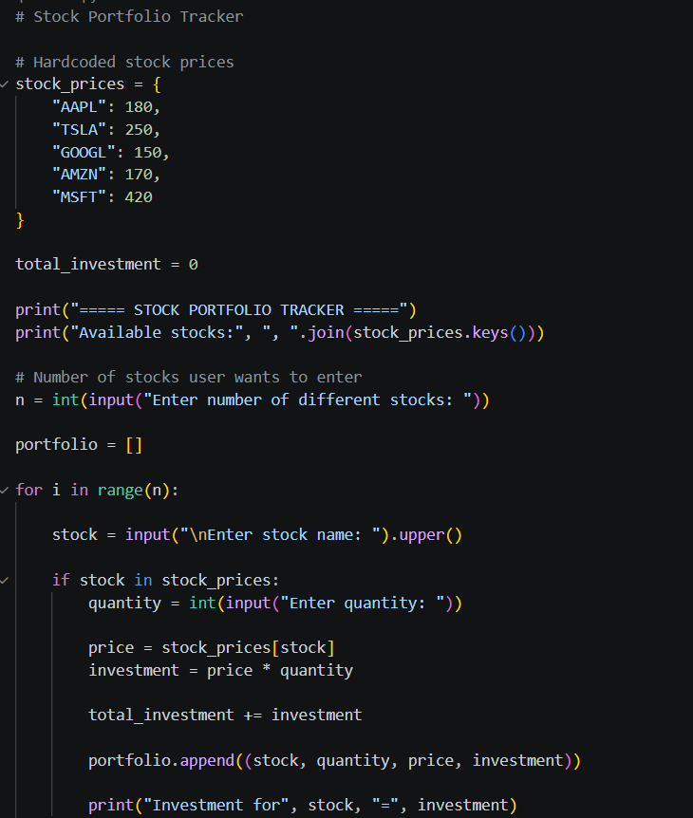
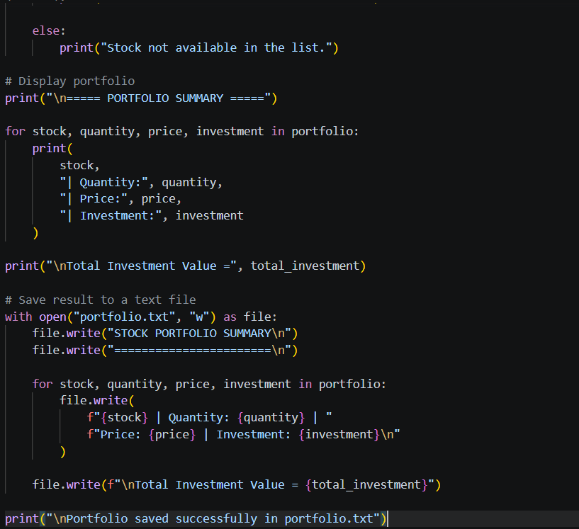
Output :
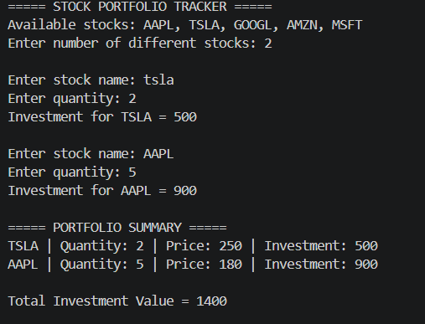
14. Conclusion
The Stock Portfolio Tracker demonstrates how Python can be used to manage simple investment data. It effectively uses dictionaries, loops, input/output, arithmetic operations, and file handling.

